CPS EXTENSION

(Variant function)

Extensions
Extension is a middleware feature available in configuration and pricing service to utilize the custom logic (variant functions) written in SAP S/4HANA for variant configuration.

Why we need to implement these Extensions?
In SAP S/4-HANA, these variant functions are written across the below listed models for deriving the dynamic sales text and product hierarchy description. In order to make the CPQ system understand and perform the same logic we make use of the Extension functionality.
This transformation is done by writing the logic in Java Script (.js file), and making it active in CPS.
We have implemented extensions in CPS for the following models.
Variant Functions | OD | KMAT
ZLBF_PLUG_TEXT | ZLBF_PLUG_TEXT | INSUL_RAIL_JOINT
ZTW_TURNOUT_TEXT | W_TURNOUT_TEXT | TURNOUT
ZCTG_PIPE_TEXT | CTG_PIPE_TEXT | COATEDPIPE
 |  | W_PIPE
 |  | W_PIPE_ID_OD
ZCTG_PRD_HIERARCHY | CTG_PROD_HIERARCHY | COATEDPIPE
ZTHR_PRD_HIERARCHY | THR_PROD_HIERARCHY | TH_CUSTOMER_PIPE
 |  | TH_PIPE
ZTHR_PIPE_TEXT | THR_PIPE_TEXT | TH_CUSTOMER_PIPE
 |  | TH_PIPE
ZWLS_FITTINGS_PRD_HIERARCHY | WLS_FITTINGS_PRD_HIERARCHY | W_FITTINGS
 |  | W_FITTINGS_ID_OD
ZWLS_FITTINGS_TEXT | WLS_FITTINGS_TEXT | W_FITTINGS
 |  | W_FITTINGS_ID_OD
ZWLS_PIPE_PRD_HIERARCHY | WLS_PIPE_PROD_HIERARCHY | W_PIPE
 |  | W_PIPE_ID_OD
ZCXT_LAGGING_TEXT | CXT_LAGGING_TEXT | LAGGING

How to implement these extensions?
These extensions support only JavaScript coding, leveraging variant functions as references, similar to ABAP code in S/4HANA. Let’s walk thought the above selected F.M (ZTHR_PRD_HIERARCHY) as an example.
Steps for creating the java script code and then upload in CPS

- Create ZTHR_PRD_HIERARCHY.js file as same name of variant function name with the extension of .js file.

- Navigate as below to check these variant functions.
- Login CPS
- Click on Extensions as below

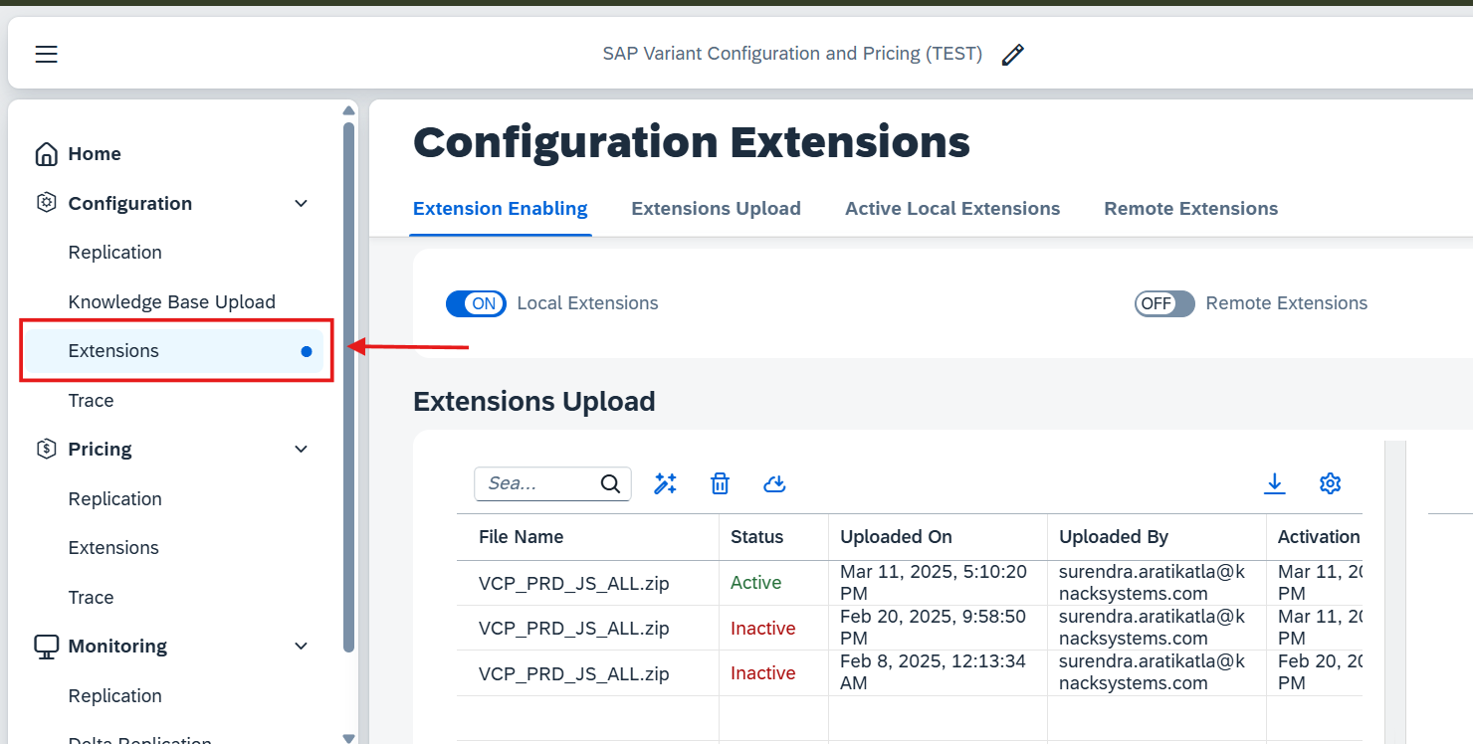

- And then click on Upload button as below

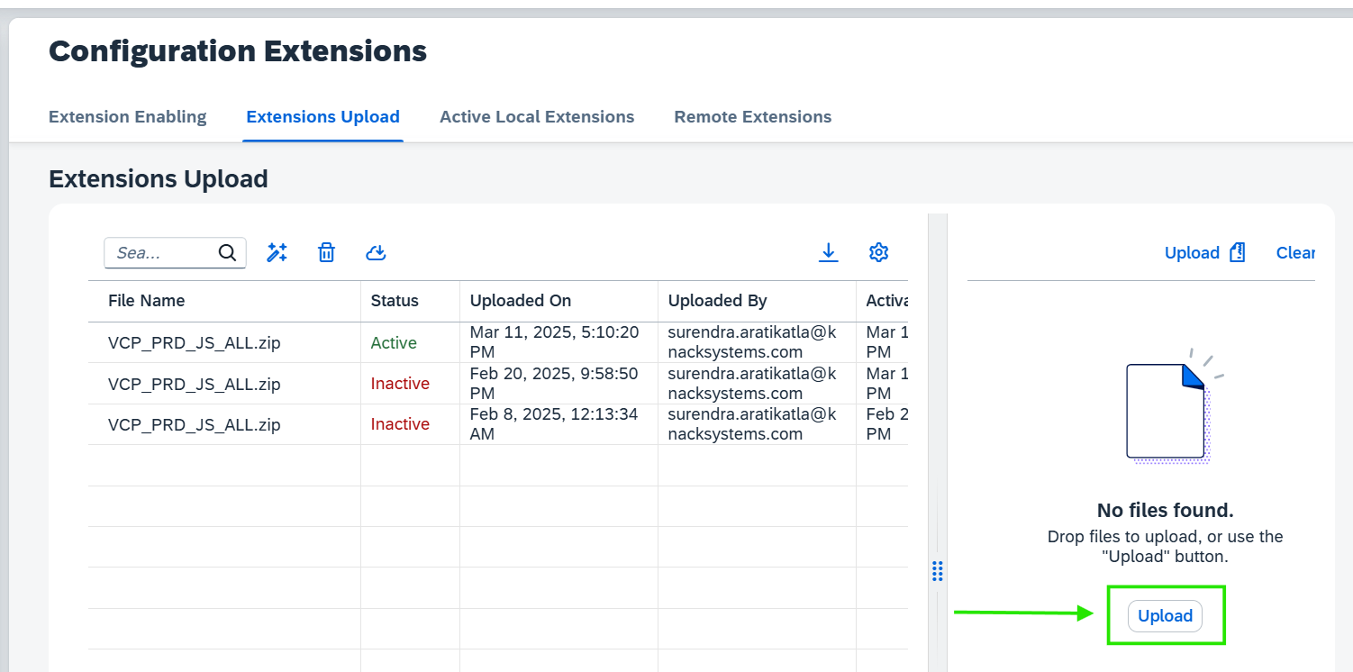

Note: Before uploading a .js file to CPS, it must be converted into a ZIP folder. You can also ZIP multiple .js files together and upload them.

- Once upload the ZIP file, at initial its having inactive status as below. But you have to select inactive cell and click on Activate / Deactivate button as I showed in below.

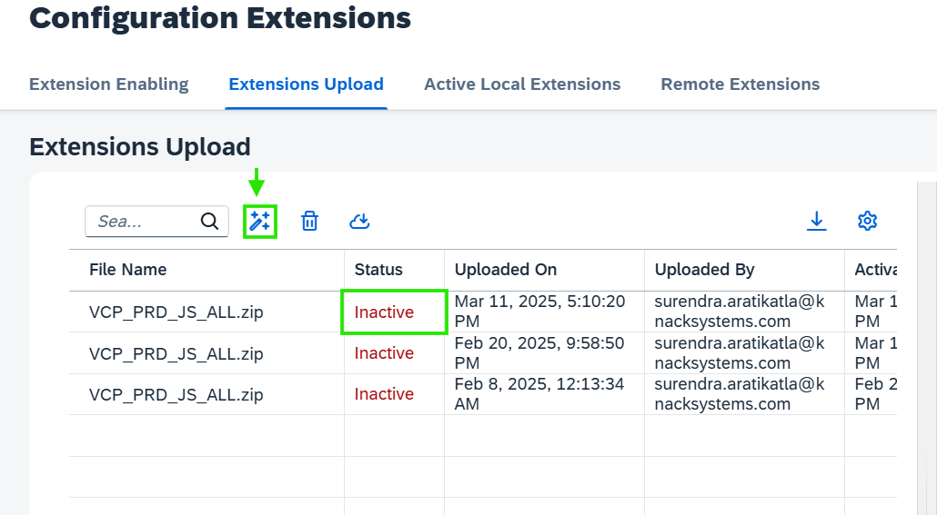

- Once you click Activate/ Deactivate button, then will active the file as below with the status.
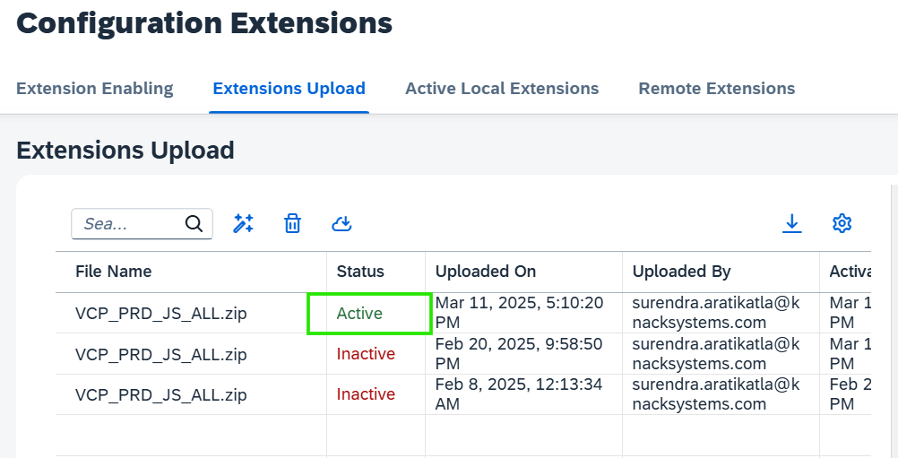

Note: In the above uploaded list of ZIP files, only one can be activated at a time.

- I provided an example above for one model. But you can repeat this process for all models, combine them into a single ZIP file, and upload it.

- Once done the process its ready to test from S4-HANA and CPQ side.

- As an example I have taken one model (TH_CUSTOMER_PIPE) and I configured in S4-HANA and CPQ with same attribute values as below in screenshot.

- And then the Product Hierarchy: THD0102154ERW RT&C is matching in both systems as below.

S4-HANA Configuration Screenshot:
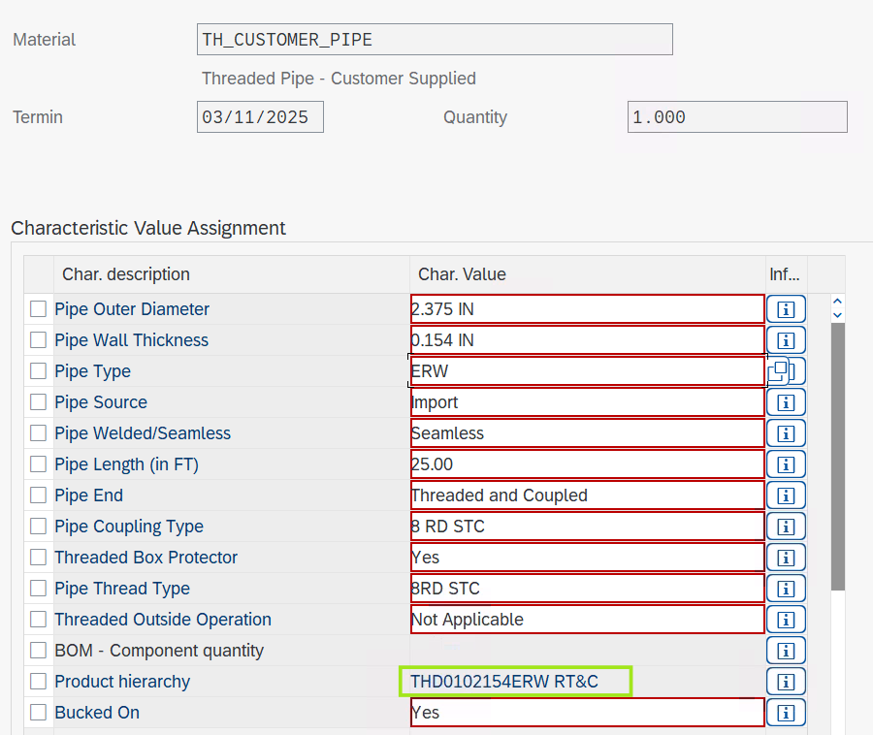

CPQ Configuration Screenshot:

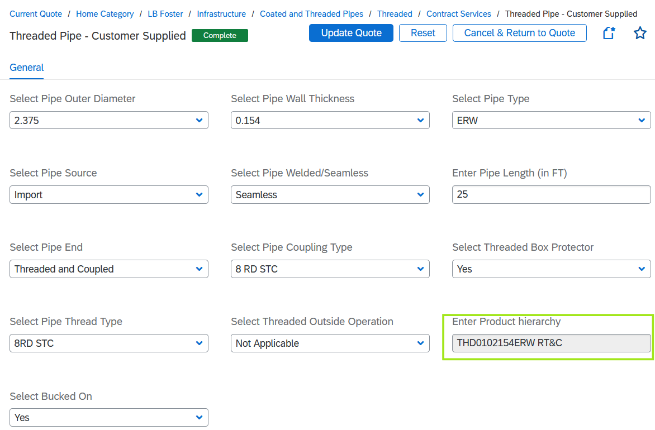

---THE END---

